**EasyKanban Manager**

EasyKanban Manager is a lightweight, Java-based console application designed to simplify task management. It allows users to register accounts, log in, add tasks with specific details, view comprehensive task reports, and exit the system. This project emphasizes efficient task tracking and secure user management in a beginner-friendly environment.

**Features**

**User Registration and Authentication**:  
- Secure account creation with credential validation.  
- Login functionality ensures only registered users access their dashboards.

**Task Handling**:  
- Add tasks with details such as name, description, assigned developer, duration, and status.  
- Automatically generates unique task IDs.

**Reporting**:  
- Generate detailed task reports by status or developer.  
- Identify the task with the longest duration.

**Data Storage**:  
- Utilizes arrays to store task details, enabling efficient data retrieval and manipulation.

**Validation**:  
- Ensures user inputs meet format requirements for usernames, passwords, and task details.

**Technologies Used**

**Programming Language**: Java

**Development Environment**: NetBeans IDE

**Version Control**: Git and GitHub

**Testing Framework**: JUnit

**Continuous Integration**: GitHub Actions

**How to Use the Application**

1. **Start the Application**:  
 Open the application in your terminal or development environment.  
  
2. **Register a User**:  
 - Enter a valid username and password to create an account.  
 - Ensure the username has an underscore and meets length requirements.  
 - Passwords should include uppercase, lowercase, digits, and special characters.  
  
3. **Login**:  
 - Provide your registered credentials.  
 - If incorrect, the system will prompt you to re-enter details.  
  
4. **Manage Tasks**:  
 - Add tasks by providing a name, description, developer, and duration.  
 - Use the task ID for easy reference or updates.  
  
5. **Generate Reports**:  
 - View task details, sorted by developers or task status.  
  
6. **Exit the Program**:  
 - Select the 'Quit' option from the main menu.

**Visual Demonstrations**

**Start the Application**:

* The application begins with a main menu providing the following options:
  + **1. Sign Up**
  + **2. Login**
  + **3. Exit**

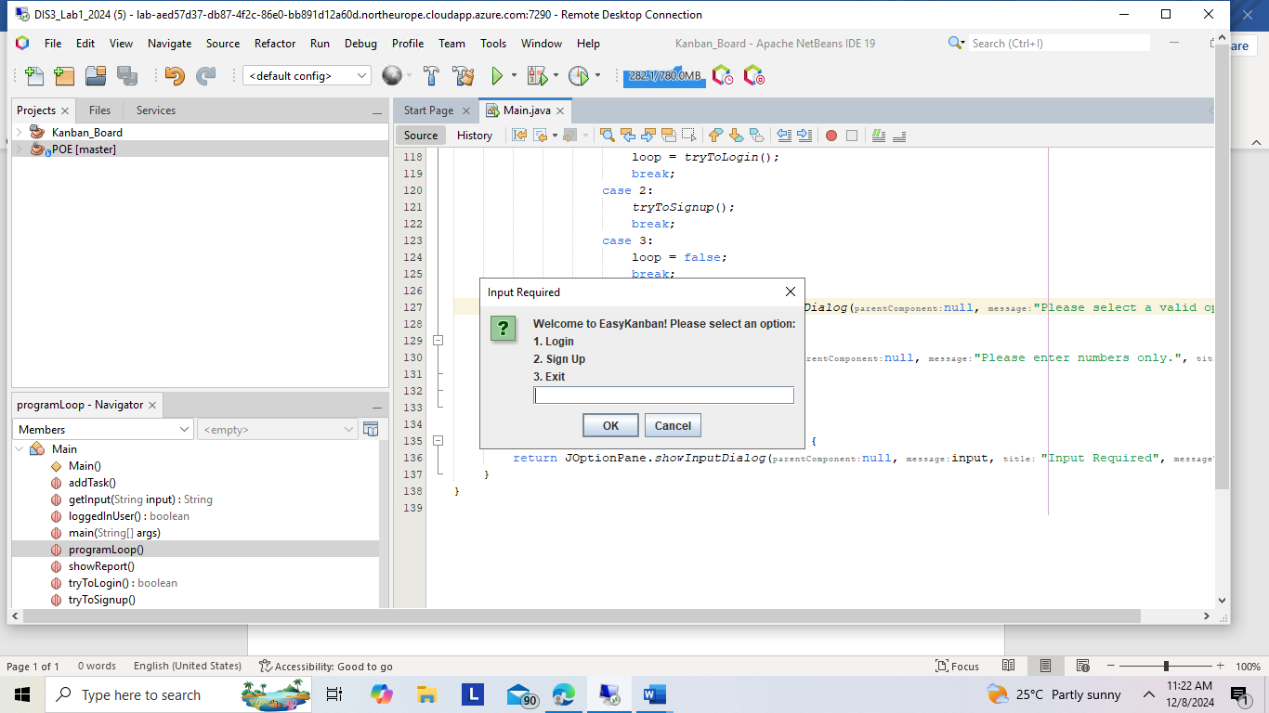

1. **Sign Up**:

* This option allows new users to create an account.
* Users must enter:
  + A valid username that contains an underscore (_) and is at least 5 characters long.
  + A strong password that includes:
    - At least one uppercase letter.
    - At least one lowercase letter.
    - At least one digit.
    - At least one special character.
* If any validation fails, the system prompts the user to re-enter the details.

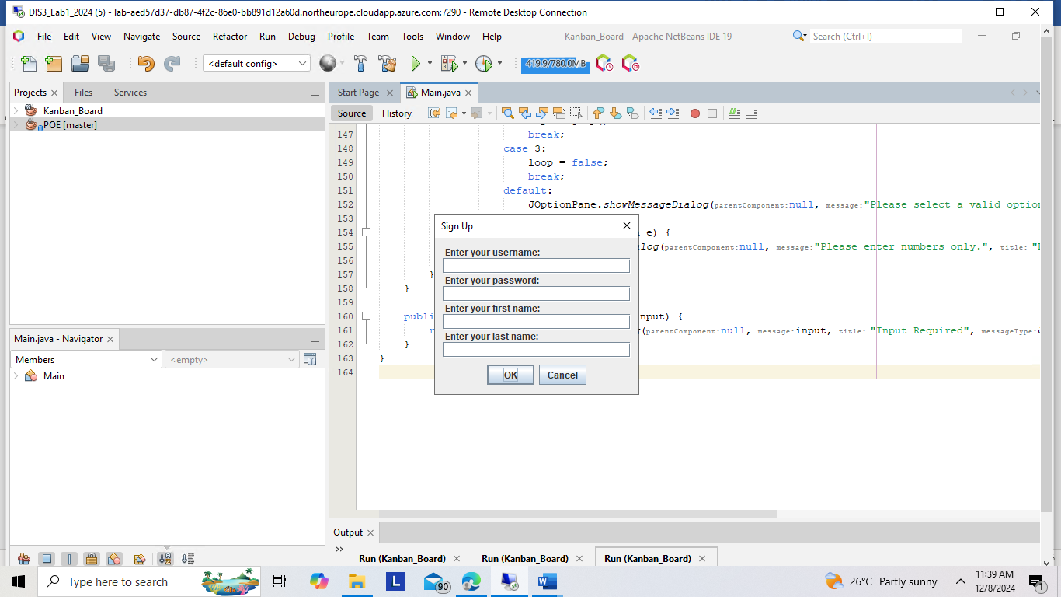

**Successful Sign-In**

* When a user provides valid credentials (username and password), the system allows access to the main menu and displays a success message.

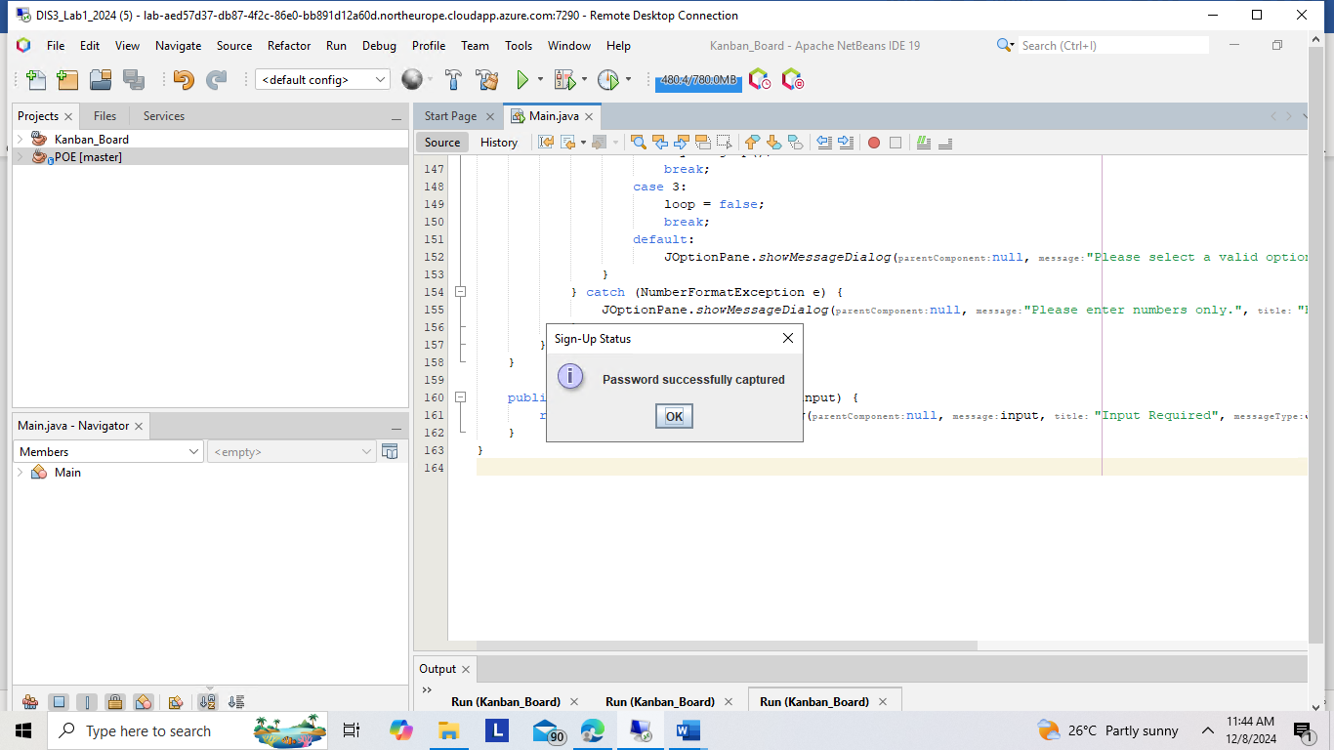

### ****Unsuccessful Sign-In****

* If the user provides incorrect credentials (e.g., an invalid username or password), the system denies access and prompts the user to try again.

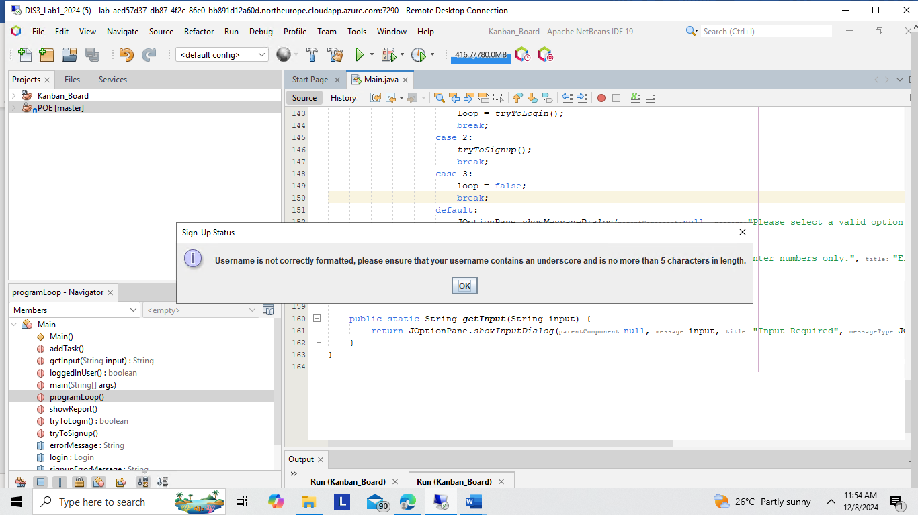

1. **Login**:

* This option enables registered users to access their account.
* Users must enter:
  + Their username.
  + Their password.
* If the credentials are incorrect, the system will display an error message and allow retries.

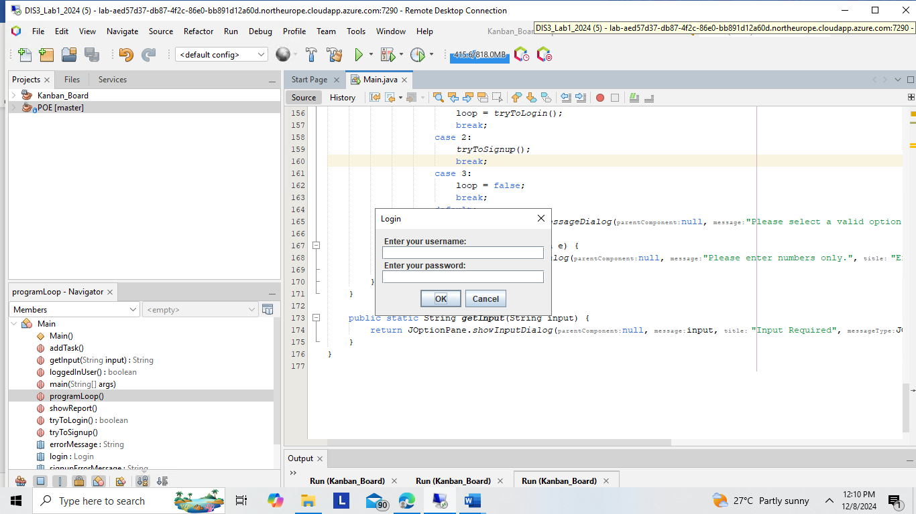

### ****Successful Login:****

This screenshot depicts a successful login attempt. The user is welcomed to the main menu after providing valid credentials.

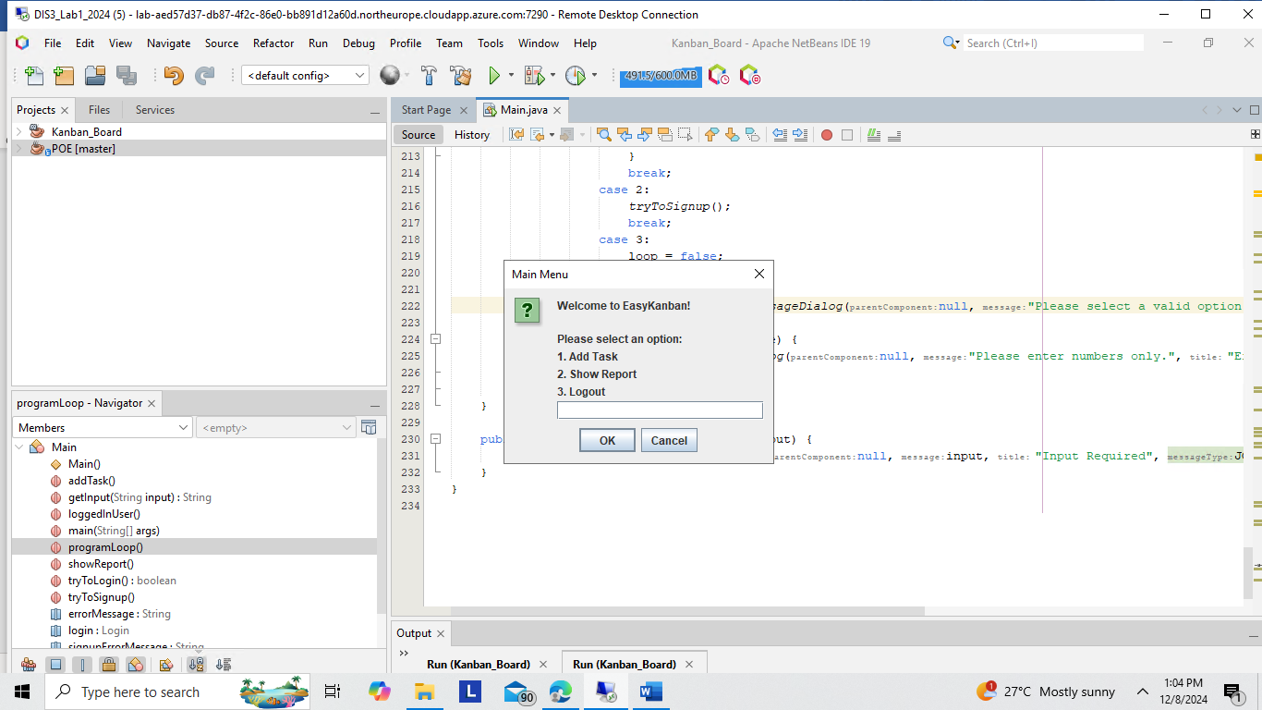

1. **Add Tasks**:

* After logging in, users can select the **Add Task** option.
* The system will prompt for:
  + Task Name: A short, descriptive name for the task.
  + Task Description: A concise description (must be less than or equal to 50 characters).
  + Developer Details: The first and last name of the developer assigned to the task.
  + Task Duration: The estimated time to complete the task in hours.
* Each task is assigned a unique Task ID generated automatically by the system.
* The system validates all inputs and displays a success message upon successful task creation.

1. **Show Reports**:
   1. Users can view a summary of all tasks they have created.
   2. Reports are grouped by task status (e.g., "To Do," "In Progress," "Completed").
   3. The system also allows filtering tasks by developer name.

1. **Exit the Program**:

* Users can exit the application by selecting the **Quit** option.
* The system ensures all processes are finalized before closing.

